Editor Manual

General Description
The MikiZaZa Editor is a side tool for the MiKiZaZa Android Application.
It enables the creation of a “Interactive Project” that will later be ran from your Android mobile phone.
In General, the editor allows the user to select online Movies, Audio Files, and Images that will be used in the project. For Each movie the user can define “Events”, and Event can be, for example, a button, hotspot or a motion gesture (such as wheel the phone right or left). The user easily defines when the event starts, ends, where it is located on the movie surface etc.
The most important properties of an event are its “Effects List” – Those define what happens when the event was fired or “missed”, for example, say we have a “button click” event, and when this button is clicked we want to display an image on a certain location, for 3 seconds and then to start playing another movie.
Two more features you should be aware of are:
- The “End of Movie Effect List” – Defines what happens when the movie ends.
- The Global Events/Global elements. In this version, a Global event is just a Text box that can be displayed on all media items (both movies and Images) and during the entire run of the project. Any interaction with this element will be ignored in this version.
When finished creating the project, the Editor generates an xml file that contains the created project details. This xml file will later be referenced from the MiKiZaZa Android Application, to run the new created project on the Android machine.

Perquisites
Before using the Editor for the first time, run a “Windows Updates”, as the following features are mandatory:
- .Net 3.5 Framework
- Windows Media Player, version 11 (or higher)
In addition, 3gp files should be set to run on Windows media player, and not on any other player. You might need to download a codec – make sure that you can watch 3gp movies in your Windows Media Player 11.

General GUI Description:
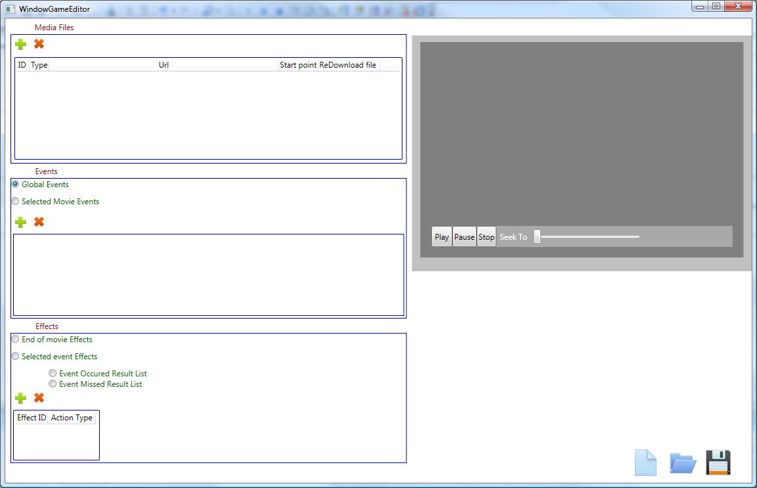
Media Files Area. List of all media files used in the Game.
The TV Surface, the selected movie will be played here.
“Open Button” – Enables loading existing xml file, for further editing.
“Restart Button” – Cleans all lists to start edit a new project.
Effects Area.
If “End Of Movie Effects” selected, then the list shows the list of effects that will occur when the movie ends.
Else, it will show either the “Event Occurred effect list” or the “Event missed effect list” according to the selected button.
“Save Button” – Generates XML that will later be referenced by the MiKiZaZa Android App.
Events Area.
If “Global events” checked then the list shows the list of Global Events. If not – It shows the list of events of the selected (highlighted) movie.

Workflow
- Using the button in the Media Files area, add all the media files you will be using in the project.
- Select the movie that will be starting the project using the “Start Point” Radio button.
- For each movie, define its Events:
  - Select (highlight) the movie you would like to add events to. Make sure the “Selected movie events” Radio button is selected.
  - Draw a rectangle over the TV surface.
  - Click the button in the “Events Area”.
  - A default “Time frame” is created for this event, that is the 10 seconds starting when clicking the + button( relatively to the movie playing of course). there are two ways to change the “time frame”.
    - First is to play the movie, and when you want the event to start, click the “Starting At” button. Do the same for when the event ends.
    - Click the “Set Manually” button to open a manual time frame set dialog.
  - The default event type is “Hot Spot”. You can use the drop down list to change the event type. Notice, for motions events (Wheel right/Left) you should also select a rectangle before clicking the “add event” button (Althought this rectangle will not appear on the Android machine)
Following is a description of all event types and their properties:
    - Hot spot. Will define a transparent rectangle.
    - ButtonClick: when selected you will see it’s property window that includes:
- Color – the backround color of the button.
- Alpha – Transparency of the color ( 0-255 value)
- On Click Color – What is the color of the button when clicked.
- Text – Text to appear on the button.
    - Text: Very similar to “ButtonClick” but when clicked doesn’t show any button click effect, and has no property for “On Click color”.
    - Movable Picture: This event type has no result list, it is actually a picture box that can be moved by the user between 2 locations. Following are the properties:
      - Image: the Image ID (media file ID) to be displayed inside this picturebox.
      - Alpha
      - NumOfFrames: a bit complicated, if you want this “MovablePicture” to be an animated gif (or animated anything), you would need to place all the images of this animation in the same loction, the first file should be named : “Filename_0.extension”, the second: “Filename_1.extention” etc. and set the “numOfFrames” property to be the number of those files.
      - Flickering: The image can flicker if selected.
      - 2nd Location: Draw a rectangle over the TV surface and then click this button. This defines the secondary location for this movable picture.
    - PictureBox: is like a button, with a picture on his background, but without the button click effect. Properties are similar to the movable picture, so will not be detailed.
    - Wheel Right/Wheel Left: the motion/gestures of the phone. No further properties available.
- For each Event, Define it’s “Event Occurred Effect List”, and the “Event Missed Effect list”, the event missed effect list defines what will be done if the event has expired (for example a button that appeared on the screen for 10 seconds, and the 10 seconds have passed without the user clicking the button).
  - Make sure the event you want to add effects to is selected (highlighted), and that the “Selected Event Effects” radio button is selected.
  - For both “Event Occurred Effects” and “Event Missed Effects” start adding the effects. As mentioned before, an entire list can be defined, for example, when the button is clicked you want to display an Image, then play an audio file, and then move to another movie.
    - Click the button in the effects area.
    - Use the drop down list to select the type of this effect. Following is the description of each effect and it’s properties:
      - KillApplication: by selecting this, the project run will be over.
      - MoveEoMovie: Select the MovieID (the media file ID of the movie you want to move to), and click the StartingAt button to open a dialog . select from which point you want the new movie to play. The “smooth” transition” indicates whether the current movie will continue to play while preparing the new movie for playback, or it will be stopped and the display will play nothing during this time.
      - Change Global Element Text: If you have any Global Element(Global Events) you can set their text when the event is fired. Use the EventID to identify the Globale element.
      - Play Audio: will play a selected audio file.
      - Show picture: will display an image file over the movie surface. Properties:
        - ImageID: the Media file ID of the requested image.
        - Duration (In Milliseconds). How long to display the image.
        - Location: First draw a rectangle to specify the location of this image, and then press the button.
        - Flickering: The Image can flicker.
        - Pause Movie? – if checked, the movie will be paused when displaying the image.

- For each movie, Define it’s End Of movie Effect list:
  - Make sure the movie you want to add the “End Of Movie Effect list” is the one that is hightlighted in the Media Files Area.
  - Make sure the “End Of Movie Effects ” radio button is selected.
  - Add the results, one by one, just like you did with the events Effects lists.
- If you were working with media files that were located locally on your pc, you would now need to locate them remotely, so that the Android application can access them as well. To do that:
- Relocate your files remotely.
- For each movie that has been relocated, change it’s URL attribute (in the media files list) to be the new location.
- If you edited one of your media files, and wish to save all the events and effects on this movie, you can place the new movie at the same URL that was previously defined for this movie, and then press the “ReDownloadFile”.
- When your project is ready, Generate the xml using the “save button”.
- Place your xml in a remote location, (e.g. Amazon S3 server) to enable access to it from the MiKiZaza Android Application.

Important: Do not leave any properties un-filled; make sure all of the images locations are set etc. leaving properties undefined can cause undesired consequences.

